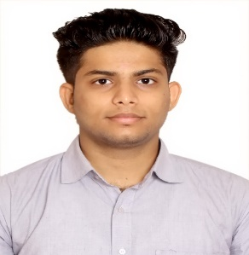SIDHARTH S

362, LIG Flats, Hastsal, Uttam Nagar, New Delhi -110059 | Contact No: 8527319859 Alternate no: 7838763717 | Email: sidharthrkc@gmail.com

# Objective

To further my professional career with an executive level management position in a world class company. Seek to diversify my skills in Industry and as part of a larger organization where I can learn and grow side by side.

# Education

|  |  |  |  |
| --- | --- | --- | --- |
| **Qualification** | **University/Institution** | **Marks /CGPA** | **Year of Passing** |
| B.Tech | Maharishi Dayanand University | pursuing | 2019 |
| 12th class | CBSE | 82.6% | 2015 |
| 10th class | CBSE | 9.2 c.g.p.a | 2013 |

# Skills & Abilities

## PROGRAMMING sTRENGTHS

* Have good knowledge in C and C++
* Have good knowledge in HTML, CSS , JavaScript and SQL
* Have good knowledge in Core Java
* Have medium knowledge in Advanced Java and

## HOBBIES

* Playing Football and Cricket
* Playing online Games in Mobile Phone
* Painting Portraits

**SOFT SKILLS**

* Quick Learner
* More reality based thinker
* Adaptable to the company norms and atmosphere
* Smart and logical worker

**Projects**

* Website made with Visual Studio 7
* UI/UX designing with Photoshop for “Facebook cloning”
* Basic JAVA applications

**Training and Certification**

* Had successfully completed 45days of training with “TEAM Computers pvt ltd”
* Have worked as a tele caller at call center at Janakpuri (west) for 3months
* Completed an online course “The Basic JavaScript Coding Breakdown ” , certified by Udemy
* Completed an online course “Web Development- CSS3- Scratch till Advanced Project based ” , certified by Udemy
* Have attended Soft skills training by Rubicon
* Have attended Aptitude Workshop held at College.

**Personal details**

* Father’s name: Mr. Sasi Kumar K
* Mother’s name: Ms. Shailaja P
* Date of birth: 26th December, 1996
* Religion: Hindu
* Marital Status: Unmarried
* Languages Known: English, Hindi, Tamil, Malayalam(Mother Tongue)

**Reference**

Ms. Rashmi Verma (Mob: 9991017865)

Head of Department

DPG Institute of technology and management

**Declaration**

I hereby declare that the above furnished information is authentic to the best of my knowledge.

Date 1st November, 2018

Place: New Delhi (Sidharth S)